21.103: a) The four possible force diagrams are:

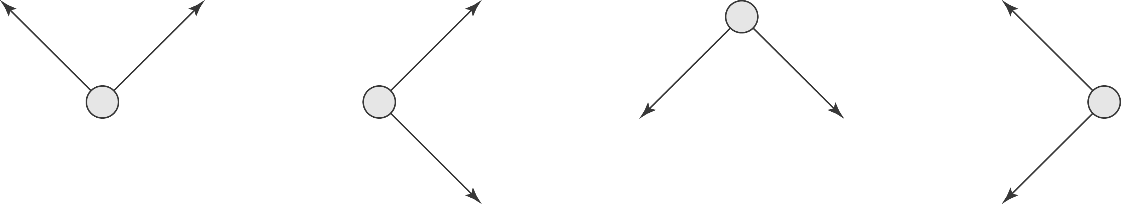
Only the last picture can result in an electric field in the –x-direction.
b)
c) 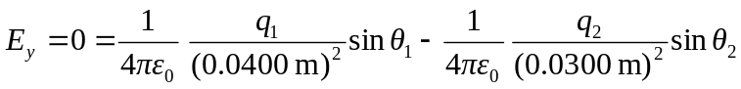
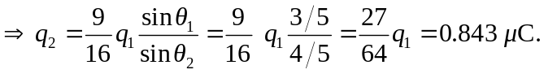
d) 